**SCHEMA DIAGRAM**

|  |
| --- |
|  |
| **Student_id name** |
| **Password** |
| **Depart_id (PK)** |
| **Email** |
| **Name** |
|  |



**Feedback_Info**

**Notes_Info**

**Notes_info**

**Notes_password**

**Teacher _id(FK)**

**Size**

**Title**

**Depart_id (FK)**

**Student_name**

**Rating**

**Feedback**

**Notes _id (PK)**

|  |
| --- |
|  |
| **Teacher_id name** |
| **Password** |
| **Depart_id(PK)** |
| **Email** |

|  |
| --- |
|  |
| **User_name** |
| **Password** |
|  |

# 0-LEVEL DATA FLOW DIAGRAM

**Student**

**Login**

**Login**

**RAPID_NOTES**

**Admin/Teacher**

**Add/Update/Delete**

**Database**

**Download/feedback**

# Submit Retrieve

**Level 1 DATA FLOW DIAGRAM**

**LEVEL 2 DFD:**

|  |  |  |
| --- | --- | --- |
|  | **LOGIN** |  |



**ADMIN**

Enter details

**LOGIN**

Verifying

Login

**RAPID_NOTES**

**ADMIN**

**GUEST**

**STUDENTS**

**TEACHER**

Uploads Notes Views Adds/views

**Department/ Notes report/ feedback**

**Downloads**

**Notes**

**Downloads Notes/ Feedback**

**Notes/Report**

# Level 2 DATA FLOW DIAGRAM

**Login**

**to system**

**Check**

**Credentials**

**Module**

**Management**

**Manage Roles of User**

**Manage user Permission**

**Manage system Admin**

**Over all View**

**Feedback Report**

**Download Notes**

**Add Department**

**Upload / delete Notes**

**ADMIN**

**Forget Password**

# Level 2 DATA FLOW DIAGRAM

**ADMIN**

**Forget Password**

**Login**

**to system**

**Check**

**Credentials**

**Module**

**Management**

**Manage Roles of User**

**Manage user Permission**

**Manage system Admin**

**Over all View**

**Feedback Report**

**Download Notes**

**Add Department**

**Upload / delete Notes**

**ER DIAGRAM DESIGN:**

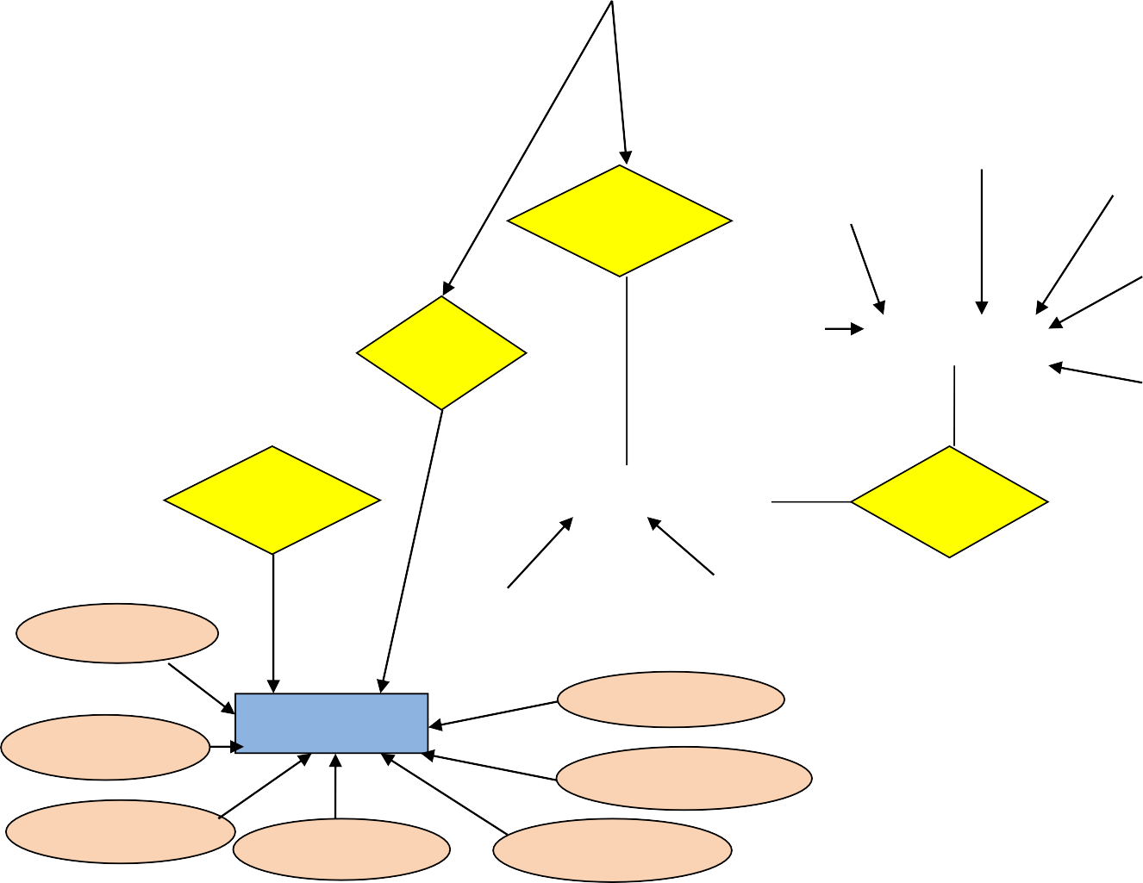

**Password**

**T_id**

1

**Feedback**

**Email**

**Name**

**Password**

Manages

**Email**

1

**Name**

**Dept_id**

**Views**

**Usn**

1

M

M M

M

**Uploads**

**Has**

1

**Dept_id**

**Dept_id**

**Dept_name**

**Notes**

**Title**

**Password**

**File name**

**Notes_file**

**Notes_id**

**Teacher_id**

**Department**

**Student**

GUEST

Notes_id



1

1

View

Notes

M

**Has**

M

1

**RAPID_NOTES**

ADMIN

Teacher